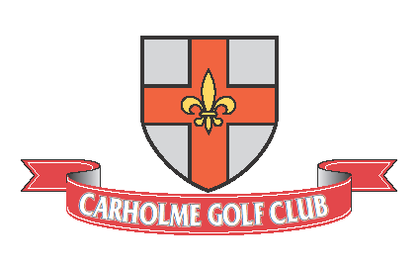
ROY BOCOCK MEMORIAL OPEN
ANY COMBINATION PAIRS
SUNDAY 23RD AUGUST 2026
FORMAT 4BBB. Handicap Limit 85%
Maximum Handicap Index Men 24.0 Ladies 32.4
Competition Handicaps Required – Proof of membership of an affiliated club will be required at registration.
Entry closes Sunday 18th August 2026.
Members Entry Fee £5 each / £10 per Pair
Visitors Entry Fee £5 each / £10 per Pair
Player 1 | Handicap | CDH No.
Player 2 | Handicap | CDH No
Contact email. | Contact Address
Preferred Tee Time:
Tel No.

CDH number can be found on your handicap certificate, howdidido, MyEG app or via your club office.
Please return the entry form together with a cheque for the entry fee (payable to Carholme Golf Club)
Or via credit or debit card by calling the club. Monday to Thursday 08:00 to 16:00
Post entries to: Competitions Manager, Carholme Golf Club, Carholme Road, Lincoln LN1 1SE
Or email entry to: competitions@carholmegolfclub.co.uk / Telephone 01522-523725
The Start Sheet will be available on the Club web site www.carholmegolfclub.co.uk the week before the competition.
Entries will not be accepted without full payment of the entry fee.
Presentation Will Be Held On The Evening Of Friday 9th October 2026.

