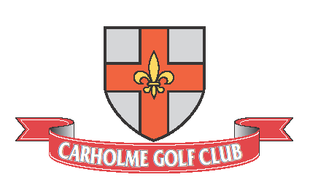
ONYX TROPHIES OPEN DAY
ANY COMBINATION PAIRS
SUNDAY 1O^{TH} MAY 2026
FORMAT 4BBB. Handicap Limit 85%
Maximum Handicap Index Men 24 Ladies 32.4
Competition WHS Handicaps Required – Proof of handicap/ CHD number will be required at registration.
Entry closes Tuesday 5th May 2026.
Members Entry Fee £5 each / £10 per Pair
Visitors Entry Fee £5 each / £10 per Pair
Player 1 | Handicap Index | CDH No.
Player 2 | Handicap Index | CDH No
Contact email | Contact Address
Preferred Tee Time
Tel No.

CDH number can be found on your handicap certificate, howdidido, MyEG app or via your club office.
Please return the entry form together with a cheque for the entry fee (payable to Carholme Golf Club)
Or via credit or debit card by calling the club. Monday to Thursday 08:00 to 16:00
Post entries to: Competitions Manager, Carholme Golf Club, Carholme Road, Lincoln LN1 1SE
Or email entry to: competitions@carholmegolfclub.co.uk / Telephone 01522-523725
The Start Sheet will be available on the Club web site www.carholmegolfclub.co.uk theweek before the competition.
Entries will not be accepted without full payment of the entry fee.
Presentation Will Be Held on The Evening Of Friday 29th May 2026.

